

Sure Trust- SKILL UPGRADATION FOR RURAL YOUTH EMPOWERMENT
Puttaparthi, Andhra Pradesh

Project Report On
Daily Art Challenge App

By
RameshwarSharanMishra (Rameshwar G30-FSD)

Under The Guidance Of
Akshara A
Trainer of Internship

ABSTRACT

The Daily Art Challenge App is a creative and community-driven mobile/web application designed to inspire artists by providing structured daily drawing prompts and fostering consistent artistic practice. In today’s fast-paced digital world, many aspiring and professional artists struggle to maintain regular practice and motivation. This application aims to solve that problem by offering a platform where users can engage in daily art challenges, track their progress, and interact with a global artistic community.
The core functionality of the app includes generating unique daily drawing prompts that encourage creativity and skill enhancement. Users can participate in these challenges by creating artwork based on the prompt and uploading their submissions within a specified time frame. To promote consistency, the app incorporates a streak tracking feature that records the number of consecutive days a user participates, thereby motivating users to maintain regular engagement.
The application is built using HTML, CSS, and JavaScript for the frontend, which ensures an interactive, responsive, and user-friendly interface. The backend is developed using the Django framework, which handles application logic, user authentication, and server-side operations efficiently. SQL database is used for storing user data, artwork submissions, voting records, and streak information, ensuring reliable data management and retrieval.
In addition to individual participation, the app emphasizes community interaction. Users can explore artwork submitted by others, like and comment on posts, and gain inspiration from diverse artistic styles. A voting system is integrated to allow users to vote for the best artwork, encouraging healthy competition and recognition of talent. Top-performing artworks may be highlighted or featured, providing visibility and encouragement to artists.
The application is designed with a user-friendly interface and scalable backend architecture to support a growing number of users and submissions. It leverages modern technologies for efficient data management, real-time updates, and seamless user experience. Security and content moderation mechanisms are also considered to ensure a safe and respectful community environment.
The integration of modern web technologies makes the application scalable, efficient, and easy to use. The project demonstrates how a full-stack web application can be developed by combining frontend technologies with a robust backend framework and database system
Overall, the Daily Art Challenge App serves as a platform that combines creativity, discipline, and social interaction. It not only helps users improve their artistic skills through daily practice but also builds a supportive community where artists can share, learn, and grow together. This project demonstrates the integration of technology with creativity to address real-world challenges related to motivation, skill development, and community engagement in the field of digital art.

INTRODUCTION

In today’s digital world, creativity is increasingly being supported and enhanced through technology. Art, which has always been a powerful medium of expression, now finds new platforms in web and mobile applications. However, one of the major challenges faced by artists—whether beginners or professionals—is maintaining consistency in practice and staying motivated over time. Without regular engagement, it becomes difficult to improve artistic skills and develop a unique style.
The Daily Art Challenge App is designed to address this problem by providing a structured and interactive platform for artists. The application offers daily drawing prompts that encourage users to practice regularly and think creatively. By giving users a new theme or idea every day, the app helps eliminate the common issue of “what to draw,” making it easier for artists to stay engaged and inspired.
This project is developed as a full-stack web application using HTML, CSS, and JavaScript for designing an interactive and responsive user interface. The backend is implemented using the Django framework, which manages application logic, handles user authentication, and ensures smooth communication between the frontend and the database. An SQL database is used to store and manage important data such as user profiles, artwork submissions, daily challenges, votes, and streak records.
The application not only focuses on individual growth but also promotes community interaction. Users can upload their artwork, view submissions from others, and participate in a voting system that highlights the best creations. This encourages healthy competition and provides recognition to talented artists. Additionally, the streak tracking feature motivates users to maintain daily participation, helping them build discipline and consistency in their artistic journey.
Overall, the Daily Art Challenge App combines creativity with modern web technologies to create an engaging and productive platform for artists. It aims to improve artistic skills, foster a sense of community, and demonstrate the effective use of full-stack development tools in solving real-world problems related to motivation and creative growth.

Scope of the Project

The Daily Art Challenge App focuses on creating a web-based platform that encourages artists to practice regularly, improve their skills, and engage with a creative community. The scope of this project includes the design, development, and implementation of a full-stack application using HTML, CSS, JavaScript (frontend), Django (backend), and SQL (database).
The application allows users to register, log in, and participate in daily drawing challenges generated by the system. Users can upload their artwork, view submissions from other participants, and interact through likes, comments, and voting features. A streak tracking system is included to monitor user consistency and motivate daily participation. All user data, artwork details, and interactions are securely stored and managed using an SQL database.
The project mainly covers the following functional areas:
- Daily prompt generation and display
- User authentication and profile management
- Artwork upload and storage
- Community interaction (view, like, comment, vote)
- Streak tracking and performance monitoring
Uniqueness of the Project
The uniqueness of the Daily Art Challenge App lies in its combination of creativity, consistency tracking, and community engagement within a single platform. Unlike general social media platforms, this application is specifically designed for artists with a structured approach to daily practice. The daily prompt system removes the difficulty of choosing what to create, while the streak feature encourages discipline and habit-building.
Another distinctive aspect is the integration of a community-driven voting system, which promotes healthy competition and provides recognition to users based on their creativity rather than popularity alone. The app also ensures a focused and distraction-free environment dedicated entirely to artistic growth.
Additionally, the use of the Django framework ensures a secure and scalable backend, while the combination of HTML, CSS, and JavaScript provides a responsive and user-friendly interface. The project demonstrates how modern web technologies can be effectively used to solve real-world problems related to motivation, consistency, and skill development in the field of digital art.
Future Scope
The project can be further enhanced by adding features such as:
- AI-based personalized art prompts
- Mobile application version
- Real-time chat between artists
- Advanced analytics for skill improvement
- Integration with social media platforms

Existing System vs Proposed System

1. Existing System
In the present scenario, artists usually depend on general-purpose platforms such as social media websites, online forums, or random art prompt generators. While these platforms provide exposure and inspiration, they are not specifically designed to support structured artistic growth, consistency, or skill improvement.
Working of Existing System
Artists search for drawing ideas manually from the internet.
They create artwork and upload it on platforms like social media.
Feedback is received in the form of likes, comments, or shares.
There is no structured tracking of progress or participation.
Limitations of Existing System
1.Lack of Structured Learning
- No proper system for daily or guided practice.
- Artists often skip practice due to lack of direction.
2.Difficulty in Idea Generation
- Users spend time deciding what to draw instead of actually practicing.
- Creativity may be blocked due to absence of prompts.
3.No Consistency Tracking Mechanism
- Existing platforms do not provide streak tracking or performance monitoring.
- Users cannot measure their improvement over time.
4.Low Motivation and Engagement
- Without goals or rewards, users lose interest quickly.
- No system to encourage daily participation.
5.Unorganized Community
- Art content is mixed with other types of content.
- Difficult to find relevant artwork or connect with artists of similar interests.
6.Unfair Recognition System
- Popularity is based on followers rather than talent.
- New or less-known artists get less visibility.

7.Lack of Centralized Data Management
- No proper system to store user progress, artwork history, or performance data.

2. Proposed System
The Daily Art Challenge App is designed as a dedicated, full-stack web application that solves the above problems by providing a structured, interactive, and motivating environment for artists.
The system is developed using:
- Frontend: HTML, CSS, JavaScript
- Backend: Django
- Database: SQL
Working of Proposed System
- Users register and log in securely.
- The system generates a daily drawing prompt automatically.
- Users create artwork and upload it to the platform.
- The system tracks user participation through a streak feature.
- Users interact with others via likes, comments, and voting.
- Best artworks are identified based on voting.
Features of Proposed System
- Daily Prompt Generation
  - Automatically provides a new drawing topic every day.
  - Removes confusion and saves time in idea selection.
  - Encourages creativity and exploration of new themes.
- User Authentication and Profile Management
  - Secure login and registration using Django.
  - Each user has a personal profile with their submissions and streak.
- Artwork Upload and Storage
  - Users can upload images of their artwork.
  - Data is stored securely in an SQL database for easy retrieval.
- Streak Tracking System
  - Tracks consecutive days of participation.
  - Motivates users to maintain regular practice.
  - Helps in building discipline and habit formation.
- Community Interaction Module
  - Users can view others’ artwork.
  - Like, comment, and engage with the community.
  - Encourages learning through observation and feedback.
- Voting Mechanism
  - Users can vote for the best artwork of the day.
  - Ensures fair competition based on creativity and quality.
  - Helps talented artists gain recognition.
- Responsive User Interface
  - Designed using HTML, CSS, and JavaScript.
  - Provides smooth and user-friendly experience across devices.
- Centralized Data Management
  - All data (users, artwork, votes, streaks) is stored in a structured database.
  - Ensures data consistency, security, and scalability.

System Architecture
The Daily Art Challenge App follows a 3-Tier Architecture:
- Presentation Layer (Frontend)
- Application Layer (Backend - Django)
- Data Layer (Database - SQL)

Architecture Diagram

User (Browser)
(Laptop / Mobile device )
HTTP Requests / Responses

Frontend (client side)
HTML | CSS | JavaScript
- UI Design
- Forms (login,Upload)
- Interaction

API Calls / Requests

Backend (Django Server)
- Buisnessn Logic
- Authentication
- Prompt Generation
- Streak Calculation
- Voting System
ORM Queries ( Django ORM)

DataBase (SQL)
- User Data
- Artwork Submissions
- Votes & Comments
- Streak Records

Explanation of Architecture
1. Presentation Layer (Frontend)
- Built using HTML, CSS, and JavaScript
- Provides user interface for:
  - Login/Register
  - Viewing daily prompts
  - Uploading artwork
  - Viewing community posts
- Sends user requests to backend via HTTP
2. Application Layer (Backend - Django)
- Core logic of the system is handled here
- Key responsibilities:
  - User Authentication (login/signup)
  - Daily Prompt Generation
  - Handling Uploads
  - Streak Tracking Logic
  - Voting & Comments System
- Uses Django framework for:
  - Security
  - Fast development
  - Clean architecture
3. Data Layer (SQL Database)
  - Stores all application data:
  - User profiles
  - Artwork images
  - Daily challenges
  - Votes and comments
  - Streak data
  - Managed using Django ORM, which connects backend to database efficiently

Working Flow (Step-by-Step)
  - User opens the app in browser
  - Frontend displays UI using HTML/CSS/JS
  - User performs action (login/upload/view prompt)
  - Request goes to Django backend
  - Backend processes logic
  - Data is fetched/stored in SQL database
  - Response is sent back to frontend
  - User sees updated result

Technology Stack Used
1. Overview
The Daily Art Challenge App is developed using a modern full-stack web development approach, combining frontend, backend, and database technologies. The main technologies used in this project are:
- Frontend: HTML, CSS, JavaScript
- Backend: Django (Python Framework)
- Database: SQL
This combination ensures that the application is interactive, scalable, secure, and efficient, while also being easy to maintain and extend in the future.
2. Frontend Technologies
The frontend is responsible for designing the user interface (UI) and ensuring a smooth user experience (UX). It acts as the communication layer between the user and the backend system.
2.1 HTML (HyperText Markup Language)
HTML is used to create the basic structure of web pages in the application.
Role in the Project:
- Designing layouts for pages like:
  - Login and Registration
  - Dashboard
  - Daily Prompt Page
  - Artwork Upload Page
  - Community Gallery
- Structuring elements such as:
  - Forms (login, upload)
  - Buttons
  - Images (artwork display)
  - Navigation bars
Advantages:
- Simple and easy to use
- Provides clear structure
- Compatible with all browsers
2.2 CSS (Cascading Style Sheets)
CSS is used to enhance the visual appearance and design of the application.
Role in the Project:
- Styling layouts and pages
- Making the UI visually attractive
- Designing responsive layouts for different screen sizes
- Adding colors, fonts, spacing, and animations
Features Used:
- Flexbox/Grid for layout design
- Responsive design techniques
- Hover effects and transitions
Advantages:
- Improves user experience
- Enables responsive design
- Separates design from structure
2.3 JavaScript
JavaScript is used to make the application interactive and dynamic.
Role in the Project:
- Form validation (login/signup)
- Dynamic content updates without reloading
- Handling user interactions (clicks, uploads, voting)
- Improving responsiveness of UI
Examples in Project:
- Checking valid email/password format
- Displaying alerts or notifications
- Updating like/vote count instantly
Advantages:
- Makes UI interactive
- Improves performance
- Enhances user engagement
3. Backend Technology
3.1 Django Framework
Django is a high-level Python web framework used to build the backend of the application.
Why Django?
- Fast development
- Built-in security features
- Scalable architecture
- Follows MVT (Model-View-Template) pattern
3.2 Role of Django in the Project
Django handles all server-side operations, including:
1. Business Logic Implementation
- Managing daily prompts
- Handling artwork uploads
- Calculating streaks
- Managing voting system
2. User Authentication
- Login and registration system
- Password encryption
- Session management
3. Request-Response Handling
- Receives requests from frontend
- Processes them
- Sends responses back
4. API Handling
- Connects frontend with database
- Transfers data securely

3.3 Django Components Used
Models
- Define database structure
- Represent entities like:
  - User
  - Artwork
  - Prompt
  - Vote
  - Comment
Views
- Handle logic of application
- Process user requests
Templates
- Connect backend data with frontend HTML
URLs
- Manage routing of web pages
Advantages of Django
- High security (prevents SQL injection, XSS)
- Rapid development
- Clean and organized code
- Built-in admin panel

4. Database Technology
4.1 SQL (Structured Query Language)
SQL is used to manage and store data in a structured format.
4.2 Role in the Project
The SQL database stores all important data such as:
- User information
- Artwork submissions
- Daily prompts
- Votes and comments
- Streak data
4.3 Database Tables
User Table
- user_id (Primary Key)
- name
- email
- password
Artwork Table
- art_id (Primary Key)
- image
- date
- user_id (Foreign Key)
- prompt_id (Foreign Key)
Prompt Table
- prompt_id (Primary Key)
- description
- date
Vote Table
- vote_id (Primary Key)
- user_id (Foreign Key)
- art_id (Foreign Key)
Comment Table
- comment_id (Primary Key)
- text
- user_id (Foreign Key)
- art_id (Foreign Key)

Advantages of SQL
- Efficient data storage
- Fast data retrieval
- Ensures data integrity
- Supports relationships using foreign keys

5. Integration of Technologies
The application works through proper integration of all layers:
- Frontend (HTML, CSS, JS)
  - Collects user input
- Backend (Django)
  - Processes logic
  - Communicates with database
- Database (SQL)
  - Stores and retrieves data

6. Tools and Environment
- Code Editor: VS Code
- Browser: Chrome
- Server: Django Development Server
- Version Control: Git

Screenshots of the codes and Project

HomePage-

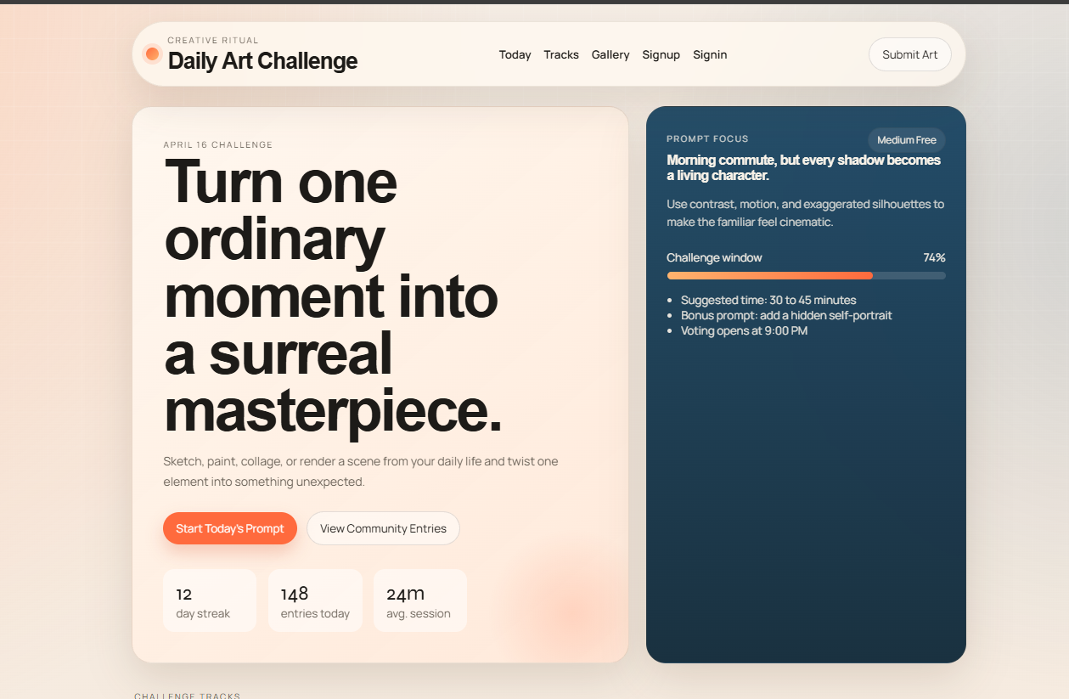
Screenshot of Main Page of App

Main Page (Homepage) Description
The Main Page (Homepage) of the Daily Art Challenge App serves as the central interface where users interact with the platform and access all major features. It is designed with a modern, clean, and user-friendly layout to provide an engaging experience while encouraging users to participate in daily art challenges.
1. Header Section (Navigation Bar)
At the top of the page, a navigation bar is provided for easy access to different sections of the application. It includes:
- App Title/Logo (Daily Art Challenge)
- Navigation links such as:
  - Today (current challenge)
  - Tracks (user progress/streaks)
  - Gallery (community submissions)
  - Signup / Signin
- A “Submit Art” button for quick access to upload artwork
This section ensures smooth navigation and improves overall usability.
2. Hero Section (Main Highlight Area)
The central part of the homepage displays the daily art challenge prompt in a visually attractive format.
Key Elements:
- Challenge Title and Date (e.g., April 16 Challenge)
- Main Prompt Text
  - Example: “Turn one ordinary moment into a surreal masterpiece.”
- Description/Instructions
  - Provides guidance on how to approach the challenge
- Call-to-Action Buttons:
  - Start Today’s Prompt → encourages participation
  - View Community Entries → allows exploration of others’ work
This section is designed to immediately grab user attention and motivate them to start creating.
3. Statistics Section (User Engagement Info)
Below the prompt, important statistics are displayed to enhance motivation:
- Day Streak (e.g., 12 days)
- Entries Submitted Today
- Average Session Time
These metrics help users track their activity and encourage consistent participation.
4. Prompt Focus Panel (Right Side Section)
A dedicated panel provides additional details about the daily challenge, making the experience more structured.
Includes:
- Prompt Explanation
  - Gives deeper insight into the theme
- Difficulty Level (e.g., Medium Free)
- Creative Tips
  - Suggestions like using contrast, motion, etc.
- Challenge Progress Indicator
  - Shows remaining time or participation progress
- Extra Instructions:
  - Suggested time (30–45 minutes)
  - Bonus prompt ideas
  - Voting schedule
This section enhances creativity and provides direction to users.
5. User Interface Design Features
- Modern UI/UX Design
  - Clean layout with proper spacing and typography
- Color Contrast
  - Light and dark panels for better readability
- Responsive Design
  - Works smoothly on desktop and mobile devices
- Interactive Elements
  - Buttons, hover effects, and dynamic content using JavaScript
6. Purpose of the Homepage
The homepage acts as:
- A starting point for daily challenges
- A motivation hub for artists
- A navigation center for all features
- A visual showcase of the app’s concept
It effectively combines creativity, usability, and engagement to provide a seamless user experience.

Sign Up Page-
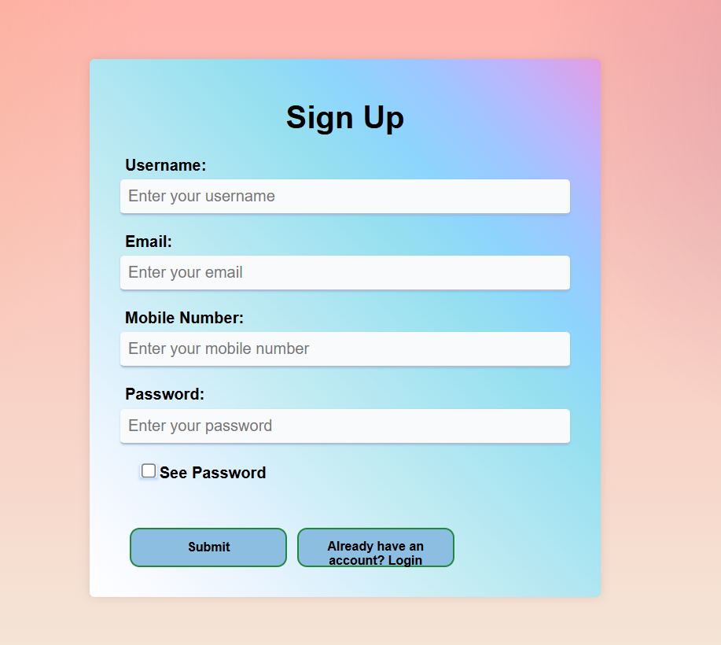
Screenshot Of Sign Up page

Sign Up Page Description
The Sign Up Page of the Daily Art Challenge App is designed to allow new users to create an account and become part of the platform. It provides a simple, secure, and user-friendly interface for user registration, ensuring a smooth onboarding experience.
1. Purpose of the Sign Up Page
The main purpose of this page is to:
- Register new users into the system
- Collect essential user information
- Enable secure access to application features such as submitting artwork, tracking streaks, and participating in challenges
2. User Interface Design
The Sign Up page is designed with a modern and visually appealing layout using a gradient background and a centered form.
Key UI Features:
- Clean and minimal design
- Soft gradient background for better visual appeal
- Clearly labeled input fields
- Proper spacing and alignment for readability
- Interactive buttons for user actions
3. Input Fields
The form collects the following user details:
- Username
  - Unique identifier for each user
  - Used for login and display purposes
- Email
  - Used for authentication and communication
  - Must be in valid email format
- Mobile Number
  - Optional/required for contact or verification
  - Accepts numeric input
- Password
  - Secured field for user authentication
  - Hidden input for privacy
4. Additional Features
Show Password Option
- A checkbox is provided to toggle password visibility
- Helps users verify their entered password
Form Validation
- Ensures all required fields are filled
- Validates email format and password strength
- Prevents invalid data submission
5. Action Buttons
- Submit Button
  - Registers the user after successful validation
  - Sends data to backend (Django server)
- Login Redirect Button
  - “Already have an account? Login”
  - Redirects existing users to the login page
6. Backend Functionality
- The form data is sent to the Django backend
- Django processes:
  - User creation
  - Password encryption
  - Data storage in SQL database
- Ensures secure handling of user credentials
7. Security Features
- Passwords are stored in encrypted form
- Input validation prevents invalid or harmful data
- Secure authentication system implemented using Django

Sign In Page –

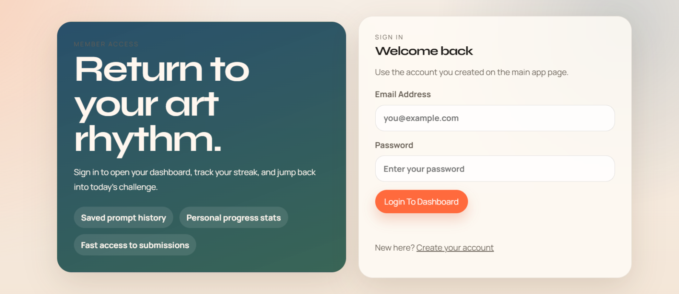

ScreenShot Of Sign In Page

Login Page Description
The Login Page of the Daily Art Challenge App allows registered users to securely access their accounts. It features a clean and modern design with a split layout. On the left side, an engaging message encourages users to continue their creative journey, highlighting features like saved prompts, progress tracking, and quick access to submissions.
On the right side, a login form is provided where users can enter their email address and password. A “Login to Dashboard” button enables users to access their personal dashboard after successful authentication. Additionally, a link is provided for new users to create an account.
This page ensures a smooth and secure login experience while motivating users to stay consistent with their art practice.

ScreenShot Of Code-
HTML Code ScreenShot
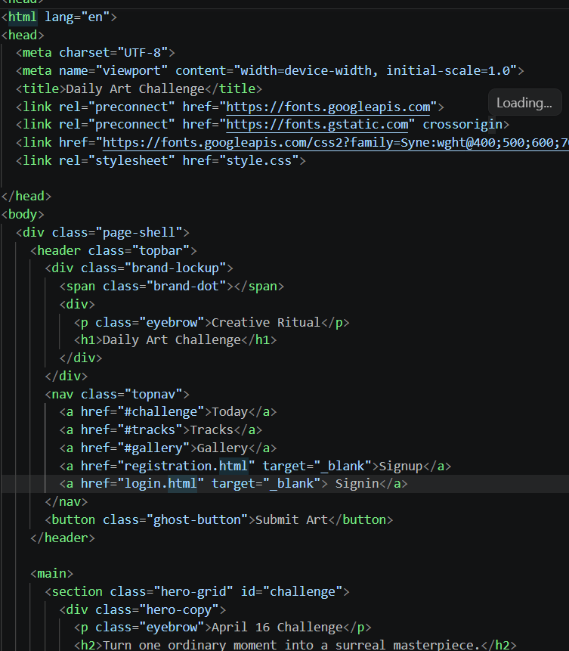

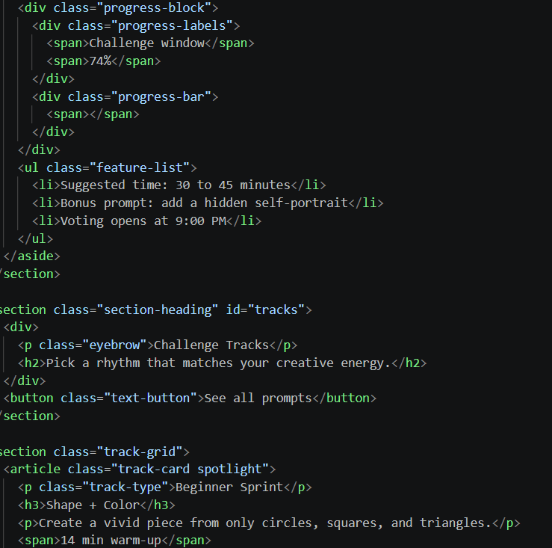
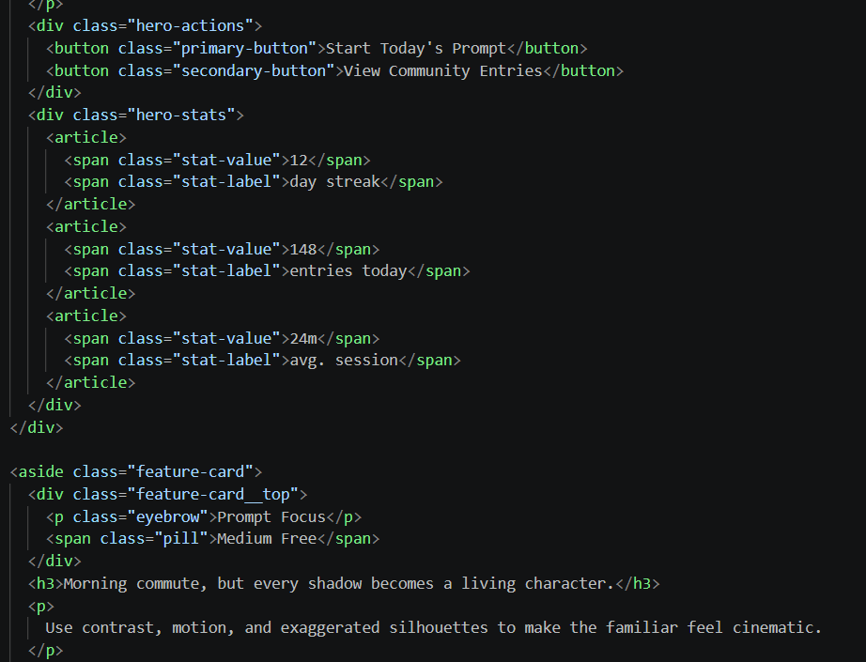
CSS Code ScreenShot-

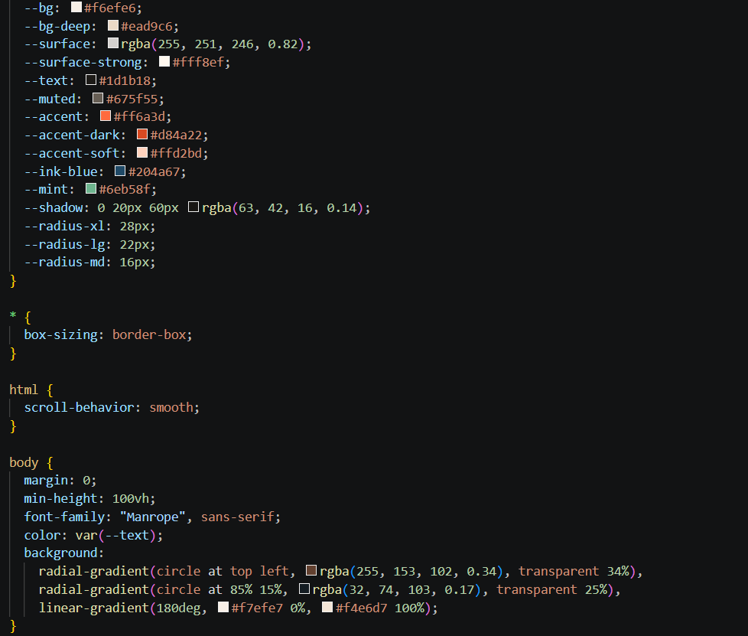

JavaScript Code ScreenShot-

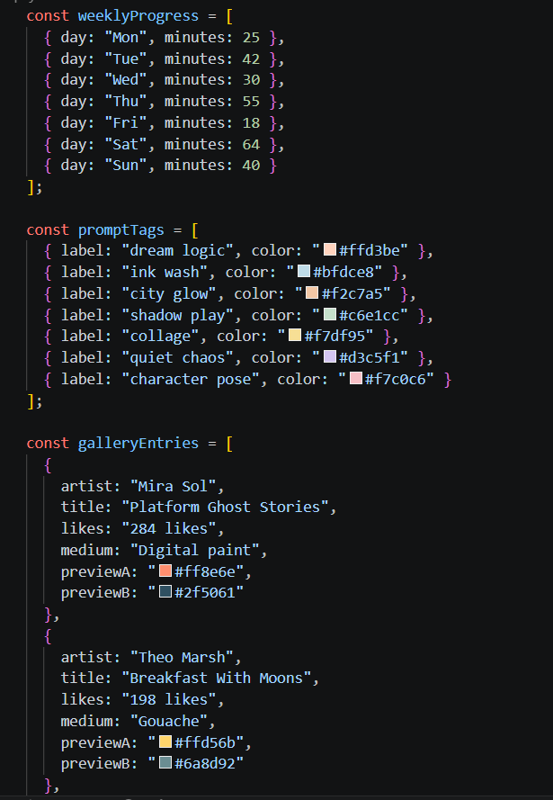

(1)

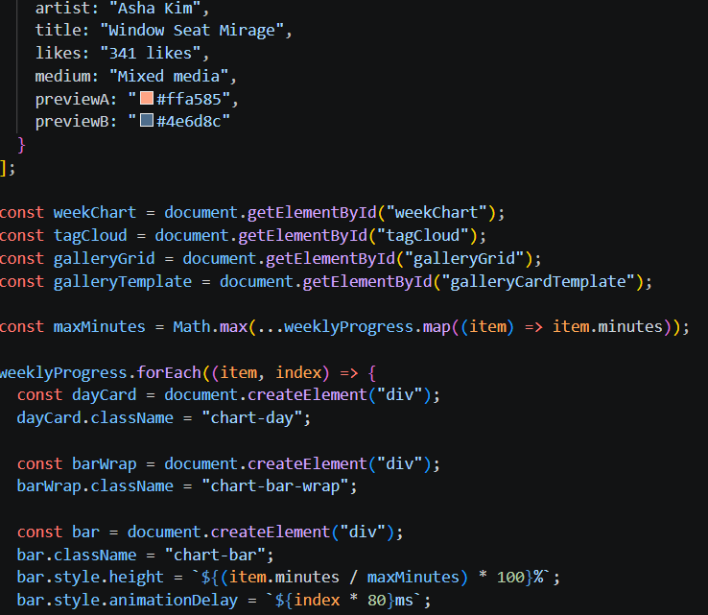
(2)

Conclusion
The Daily Art Challenge App successfully demonstrates how technology can be used to promote creativity, consistency, and community engagement among artists. The main objective of the project—to provide a structured platform for daily art practice—has been effectively achieved through the implementation of features such as daily prompts, artwork submission, streak tracking, and community interaction.
The application was developed using a full-stack approach with HTML, CSS, and JavaScript for the frontend, Django for backend development, and SQL for database management. This combination ensured a responsive user interface, efficient data handling, and secure user authentication. The integration of these technologies resulted in a smooth and user-friendly experience.
One of the key strengths of this system is its ability to motivate users through consistency tracking and a voting-based recognition system. Unlike traditional platforms, this application provides a focused environment specifically designed for artists, helping them overcome creative blocks and maintain regular practice. The community features further enhance learning by allowing users to share their work, receive feedback, and gain inspiration from others.
Throughout the development process, the project also highlighted the importance of proper system design, database management, and user interface planning. It provided practical experience in building a real-world web application and understanding how different components interact within a full-stack system.
In conclusion, the Daily Art Challenge App is an effective solution for encouraging artistic growth and building a creative community. It not only fulfills its intended objectives but also lays a strong foundation for future enhancements such as AI-based prompts, mobile application development, and advanced analytics. This project showcases the potential of combining creativity with modern web technologies to solve real-world problems in an innovative way.

